Council Minutes – November 27th, 2022
Prepared by Margaret Ann Gillis, Deputy Chair

Agenda of November 27th Council Meeting
- Call to Order
- Roll Call
- Land Acknowledgement
- Opening Remarks of the Chair
- Approval of the Agenda
- Approval of the November 13th Council Meeting Minutes
- Faculty Representatives’ Reports
- Executive Reports
- Students’ Union General Manager Report
- Special Reports to Council
  - 25-minute presentation from Lydia re: Students Nova Scotia (SNS)
- New Business
  - A motion to approve the following MyVirtual Doctor referendum question: “Do you support StFXSU implementing a Virtual Care Program that will provide students with individual access to qualified health care through a virtual platform 24hrs per day, 7 days per week to address many of the common concerns faced by students? The cost would be $44.85 per year (tax included). Students may choose to opt-out annually from this service without any conditions for a full refund.”
  - A motion to move the referendum dates to coincide with the dates of the general election for the MyVirtual Doctor referendum.”
  - A motion to approve the proposed MyVirtual Doctor referendum question to be added to the general election ballot.
  - A motion to appoint Francisco Chang as representative for the MyVirtual Doctor referendum.
  - A motion to approve 50% plus one vote (of voters) for the referendum question.
  - A motion to approve the following By-Law referendum question: “Do you support StFXSU implementing the proposed new By-laws that modernize and provide consistency between the SU governing documents? These By-laws will come into effect immediately and will replace the current By-laws of the Student Union.”
  - A motion to move the referendum dates to coincide with the dates of the general election for the By-law referendum.
  - A motion to add the proposed By-law referendum question to the general election ballot.
  - A motion to appoint Julia Schmitt as the representative for the By-law referendum.
  - A motion to “approve a 50% plus one vote (of voters) for the referendum question.
- Closing Remarks of the Chair
- Adjournment
- Appendix Items
  - SU Interim Sexual Violence Response Policy
  - Bylaw Referendum Approval

Students’ Union Representative Council Meeting
November 27th, 2022 | 12:00pm – 1:47pm ADT
Indigenous Student Lounge, Coady West, St. FX University

Call to Order
Molly: “I call this meeting to order at 12:00pm.”

Roll Call
VP Activities & Events – Kali Beaton
Chair of Council – Molly Burke
VP Finance & Operations – Sam Delaney
VP Residence Affairs – Sophia Fabiano
VP External Affairs – Ben Fairhurst
VP Academics – Naomi Stobart
President & CEO – Brendan Roberts
International Student Representative – Francisco Chang
Business Representative – Dylan Clark
Deputy Chair of Council – Margaret Ann Gillis
Arts Student Representative – Jack Harding
Indigenous Student Representative – Sierra Julian
Board of Governor Representative – Josh Kroker
First Year Representative – Christian Lejeune
General Manager – Sean Ryan
Graduate Student Representative – Julia Schmitt
Equity Representative – Caspian Tohidian

Absent with Regrets
Indigenous Student Representative – Harmony Bright-Doucette
Science Student Representative – Meredith Cudmore-Keating
Board of Governors Representative – Violet Silva

Land Acknowledgement

Molly: “I would like to begin by acknowledging that we are in Mi’kma’ki, the ancestral and unceded territory of the Mi’kmaq People. This territory is covered by the Treaties of Peace and Friendship, which Mi’kmaq and Wolastoqiyik (Maliseet) peoples first signed with the British Crown in 1725. The treaties did not deal with the surrender of lands and resources but in fact, recognized Mi’kmaq and Wolastoqiyik titles and established the rules for what was to be an ongoing relationship between nations. As a Wolastoqiyik student on Mi’kmaq land, I will continuously educate myself on what it means to be on this land that I am on and work to be an ally for the Mi’kmaq people.”

Opening Remarks of the Chair
Molly: “I call this meeting to order at 12:02pm.”
Molly: “Welcome to the Indigenous centre! It’s important to learn about this space because we are in Mi’kma’ki, and it is our responsibility to learn more about Indigenous culture and history.”

Approval of the Agenda
Josh: “I move to approve the agenda.”
Jack: “I second.”
No Discussion.
Jack: “I will call to question.”
Josh: “I second that.”
Motion passes unanimously.

Approval of the Minutes of November 13th Council Meeting
Brendan: “I will move to approve the November 13th Council minutes.”
Julia: “I will second.”
No discussion
Jack: “I call to question.”
Josh: “I second.”
Motion passes unanimously

Constituency Reports
Please see the November 27th Council Package for Constituency Reports. Below is any discussion had concerning reports.

First Year Representative – Christian Lejeune
Business: Has been hearing a lot from first-year students about a lack of confidence in ResLife’s ability to address sexual violence in an effective manner.

Discussion:
Naomi: “Thank you for bringing this up, Christian. That makes me very disappointed to hear as sexual violence prevention falls under my portfolio. I will definitely be looking into this further.”

Executive Reports
Please see the November 27th Council Package for Constituency Reports. Below is any discussion had concerning reports.

Vice President Residence Affairs – Sophia Fabiano
Internal (to portfolio):
- I have been having meetings weekly with Elizabeth Yeo and other members of the StudentLife office, Kali Beaton (VPAE) and Brendan Roberts (President) about updates from The U and the Student Life Office, as well as Residence Renewal.
- Unfortunately both weekly meetings during this reporting period were cancelled
- I have been attending weekly Executive Meetings with the other Executives.
- Had my weekly meetings with Matt Girard for updates
- Both of these were cancelled as well for various reasons - Had travelling hours in Riley Hall
- Campus Event Committee
- Charity ball was unfortunately canceled
- We are currently discussing plans for next semester
- I am having a group interview for the rest of the committee this week
External (to portfolio):
- Sat on various meetings for the VP Advancement Hiring Panel - had out final round of interviews for the committee
- Completed my LSI 360 Assessment and will be meeting to debrief soon
- Attended Group Process Training with the Team following completion of our LSI’s
Committees:
- Res Renewal Advisory: Did not meet during this period
- FSLC: Did not meet during this period
Sub-executive:
- House Council Coordinator: Broden is back and helping me with the committee and house points
- OCL: Nothing new to report
- Student Advocates: Nothing new to report
Outreach:
- I spent an evening in Riley Hall chatting with students and answering questions
- Did the polar plunge for Movember
- Attended the Chaplains Breakfast

Student Union General Manager’s Report
General Manager – Sean Ryan
Sean: “Hey everyone! Just a couple quick things from the full-time staff. Julianne and Matthew have been getting things with X-Ring sorted out on the backend. The Marketing team is getting ready to finish the year strong and get the screens updated with our hours of operation for DriveU and Kevin’s Corner. Sam forgot to mention that Kevin’s Corner’s exam snack program will be running during exams to provide students with free study snacks, so we’ll be looking for groups of volunteers to go out between 2-4 during exam week armed with backpacks of snacks to hand out to students. We’ll be including the councillors and exec team in our search for volunteers.
Movember’s wrapping up and we had our last official event on Friday. Jacqueline DeLeebeeck burned our insides out for $1400 in donations. Also, Bob Hale and I are close to releasing our music video of Let Your Love Flow soon if we get enough donations.
Sean, our bar manager, is getting ready for big events this weekend. Victoria Paddon has been doing some awesome work making sure we’re up to date with the store.”
No discussion.

Special Reports to Council
25-minute presentation from Lydia, “Students Nova Scotia (SNS).”
Overview: SNS is a nonpartisan, non-profit association representing students from St. FX, Acadia, St. Mary’s and CBU. Lydia is executive director for SNS, and Ben, Brendan and she have been in Ottawa for the past week or so lobbying the federal government advocating for better financial aid for post-secondary students.
Discussion:
Jack: “What are the biggest challenges for you guys in accomplishing these goals right now? Where can the rest of campus step in to help get there?”
Lydia: “Student engagement is always a challenge in this sort of work. This is such a high-level sort of thing, student leaders meeting with government. Whether it’s through campaigns or just talking to students about SNS, that student engagement piece is really important.”
Brendan: “I’d agree, Lydia. We’re paid to do this so of course we’re going to take the time and care about it, but for the average student who isn’t in these spaces sometimes it’s harder to get them to understand or realize what’s happening. You don’t need to go at it and give them a whole presentation, but just say like, ‘SNS represents you and they meet with federal government,’ to help people learn more and become engaged in what we do. It comes across to government better when there are more students buying in and supporting us.”
Ben: “Yeah, prior to coming into this role last year, SNS never had a face, or a person tied to it. I wanted to strive to make this role like a friendly face you can come in and chat with. Affordable housing is a big one – even though it’s something everyone’s going through, even if you want to have a conversation about that – there’s still a role for government to play. That’s the weird part about it that makes this role seem really foreign, but just the things you’re hearing from your constituency. Bring that up and it allows us to better represent everyone moving forward.”
Josh: “On which recommendations are you seeing the best traction?”
Lydia: “I would say there’s a lot of conversations happing around OER right now. I think especially within the context of NS, we have a focus on strengthening our workforce and growing our population, so co-op there has been a lot of conversations around. Also, the number of conversations around affordability – whether it’s inflation or tuition. Overall, the three I’m hopeful to see traction on are those three.”
Brendan: “I’d agree with that.”
Jack: “What’s coming up next?”
Brendan: “So we have a couple for meetings this week, so me and Ben are going back to Halifax this week. We have a meeting with Minister of Advanced Education Brian Wong, and Marcel’s going to Halifax tomorrow to meet with Zach Churchill, leader of the NS Liberal Party.”

New Business
A motion to approve the following MyVirtual Doctor referendum question: “Do you support StFXSU implementing a Virtual Care Program that will provide students with individual access to qualified health care through a virtual platform 24hrs per day, 7 days per week to address many of the common concerns faced by students? The cost would be $44.85 per year (tax included). Students may choose to opt-out annually from this service without any conditions for a full refund.”
Discussion:
Dylan: “Will they be automatically entered?”
Molly: “They can opt in or opt out.”
Sam: “It’s like the health plan; you’re opted in automatically, but you can opt out.”
Caspian: “What kind of doctor is this? A family medicine doctor or speciality?”
Sam: “It’ll be a nurse practitioner or an intake nurse.”
Caspian: “What about OBGYNs or gynecologists?”
Sam: “For this one, they can do the referral, but they can’t push any harder than any other doctor could. But your official intake here would be faster.
Julia: “With the health and dental plan, if you opt out of it, you can’t opt back into it. With this one, can you opt back in?”
Sean: “That’s incorrect. You can opt back into the plan if you wish. You have from September 1st to September 30th each year to opt in or out of the program.”
Josh: “I’ll motion.”
Dylan: “I’ll second that.”
No discussion.
Naomi: I’ll call to question.
Jack: I’ll second that.
Motion passes unanimously

A motion to move the referendum dates to coincide with the dates of the general election for the MyVirtual Doctor referendum.”
No discussion.
Josh: “I’ll move.”
Brendan: “I’ll second.”
No discussion.
Naomi: “I’ll call to question.”
Jack: “I’ll second.”
Motion passes unanimously.

A motion to approve the proposed MyVirtual Doctor referendum question to be added to the general election ballot.
Discussion:
Brendan: “I’ll move.”
Jack: “I’ll second.”
No discussion.
Naomi: “I’ll call to question.”
Julia: “I’ll second.”
Motion passes unanimously.

A motion to appoint Francisco Chang as representative for the MyVirtual Doctor referendum.
Discussion:
Naomi: “I just want this on the record, this is allowed right?”
Molly: “Yes.”
Naomi: “I’ll move.”
Jack: “I’ll second.”
No discussion.
Josh: “I’ll call to question.”
Dylan: “I’ll second.”
Motion passes 9/1/0.

A motion to approve 50% plus one vote (of voters) for the referendum question.
Discussion:
Naomi: “I’ll move.”
Brendan: “I’ll second.’
No discussion.
Josh: “I’ll call to question.”
Francisco: “I’ll second.”
Motion passes unanimously.

A motion to approve the following By-Law referendum question: “Do you support StFXSU implementing the proposed new By-laws that modernize and provide consistency between the SU governing documents? These By-laws will come into effect immediately and will replace the current By-laws of the Student Union.”
Discussion:
Josh: “I’ll move.”
Jack: “I’ll second.”
Brendan: “This question is going to be posed to the students to ask them if they agree to the proposed By-laws.”
Brendan: “I’ll call to question.”
Naomi: “I’ll second.”
Motion passes unanimously.

A motion to move the referendum dates to coincide with the dates of the general election for the By-law referendum.
Discussion:
Naomi: “I’ll move.”
Julia: “I’ll second.”
No discussion.
Josh: “I’ll call to question.”
Dylan: “I’ll second.”
Motion passes unanimously.

A motion to add the proposed By-law referendum question to the general election ballot.
Discussion:
Francisco: “I’ll move.”
Naomi: “I’ll second.”
No discussion.
Jack: “I’ll call to question.”
Josh: “I’ll second.”
Motion passes unanimously.

A motion to appoint Julia Schmitt as the representative for the By-law referendum.
Discussion:
Jack: “I’ll move.”
Naomi: “I’ll second.”
No discussion.
Josh: “I’ll call to question.”
Naomi: “I’ll second.”
Motion passes 9/1/0.

A motion to “approve a 50% plus one vote (of voters) for the referendum question.
Discussion:
Francisco: “I’ll move.”
Jack: “I’ll second.”
No discussion.
Naomi: “I’ll call to question.”
Francisco: “I’ll second.”
Motion passes unanimously.

Closing Remarks
Molly: “Yeah! So you’re going to see both of those on the ballots in the general election. This was our last council of the semester.”
Naomi: “I know she isn’t here, but this is Meredith’s last official council and she’s served on council for the past few years and given us lots of help. Thank you, Meredith, for your mentorship and dedication!”

Adjournment
Josh: “I’ll move to adjourn.”
Brendan: “I’ll second.”
No discussion.
Motion passes unanimously.
Meeting adjourned at 1:47pm ADT.

Appendix Item I
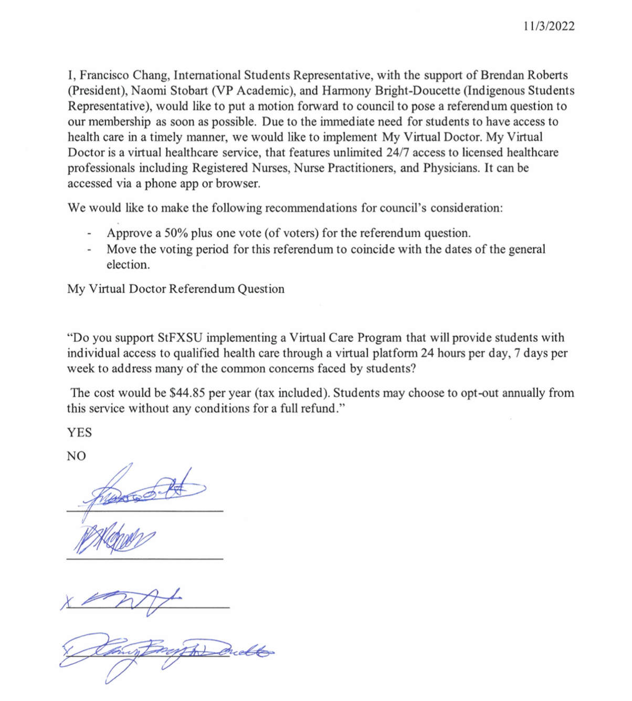

Appendix Item II
